Love the Star
Rev. Rusty Eidmann-Hicks
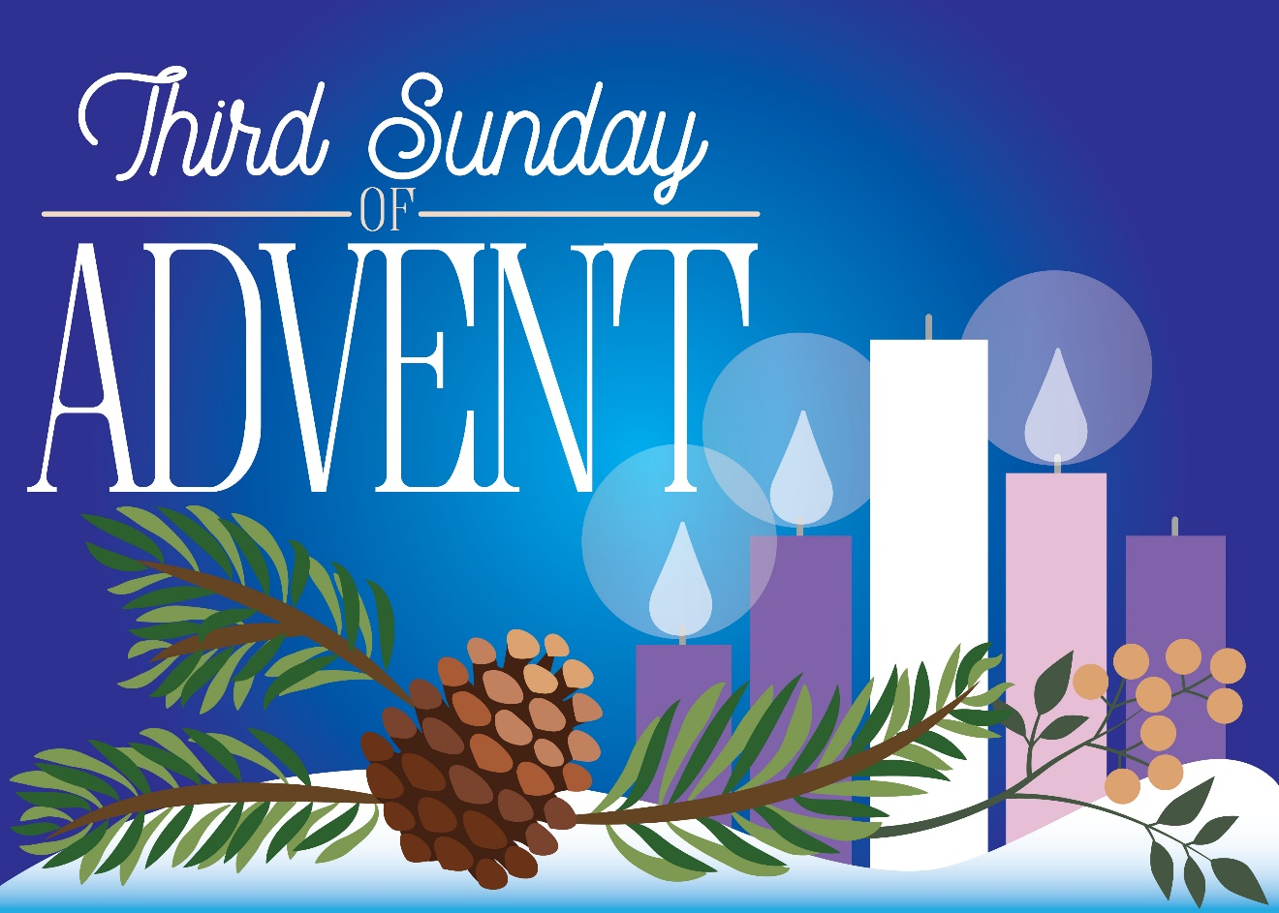
Luke 1:39-45 December 15, 2024 GRCC

After days of cloudy wet weather out at sea the sky clears and the North Star steers our ship into safe harbor. Like seeing the first evening star as a child and singing "star light, star bright, first star I see tonight…" we long for direction, for a guiding light. Too often we feel unmoored, at sea, unsure of our direction and calling. The Star of Bethlehem points us home.

Far, we’ve been traveling far,
Without a home, but not without a star . . .
Neil Diamond, from the song Coming to America

Love the star is on the way. The wise sages followed that star wherever it led, until it came to stop over the place where the Christ child lay. It doesn't make any sense scientifically; of course, stars don't get up and move around - and if they do, they’re really comets or meteors burning in through our atmosphere – or in New Jersey, maybe they’re dones! But this does make sense spiritually. God does guide wise women and men. God directs us, points out a path for us toward the holy, to heavenly peace. God does not leave us desolate. God comes to us. We are mysteriously led to the fulfillment promised by God.

For Mary it was a lot easier than for most of us. The spirit shone into her life. The angel Gabriel visited her and announced that the holy child of God would be born within her. The holy grew inside of her. It overshadowed her, wrapped around her like angel wings, and took over her life. She consented to this. “Let it be with me according to your word.”

The Franciscan brother Richard Rohr writes about what it means to say yes and to be present like Mary to the Spirit: “When you are fully there, you will know. When you are fully present, the banquet will begin. When all three inner spaces (heart, mind, and body) are open and listening together, you are present. To be present is to know what you need to know in the moment. Jesus’ mother, Mary, is a model of such presence. Her kind of yes does not come easily to us. It always requires that we let down some of our boundaries, and none of us like to do that… Mary somehow is able to calmly, wonderfully trust that Someone Else is in charge…. Her ‘yes’ is pure and simple in its motivation, open-ended in intent, and calm in confidence.”

When I find myself in times of trouble, Mother Mary comes to me,
Speaking words of Wisdom, Let it be.

For Elizabeth also, it was easy to recognize the presence of the sacred, and the mystery of God working in her life. The moment she saw her young cousin Mary standing at the doorstep of her home, the child within her did a leap, a summersault, a trampoline bounce inside of her. I can’t imagine what that would feel like. As a man, I have no clue; the closest I’ve come is indigestion. Elizabeth, filled with the Holy Spirit, proclaimed with a loud cry, “Blessed are you among women, and blessed is the fruit of your womb.” You could say that Elizabeth was the first to recognize the coming of Jesus into the world. But no, John the Baptist, the child in her womb was the first. He figured it out in utero! And then so did Elizabeth and Mary. Mary proclaims:

“My soul magnifies the Lord, and my spirit rejoices in God my savior.
For he has looked with favor on the lowliness of his servant.
Surely from now on all generations will call me blessed.”

Indeed, that has come to pass. Mary is called “Theotokis” – or “God bearer”. She held the sacred within her and brought it to fruition. She didn’t have to wait to allow a star to guide her to the sacred. Most of us, though, are not so lucky. We have to figure it out on our own, to go on a journey, to ponder the mystery of where we are meant to go. God doesn’t often give us a dream or a smack on the head to get us to head down the right path. But it does happen – it really does – miracles occur, when we see that the holy is clearing a path for us to follow. Let me share with you a wonderful Christmas story which illustrates the guiding power of the Star of Bethlehem. It’s by Jane Moschenrose, a pastor, who shares this story entitled “The Christmas Tree: A Story of Synchronicity.”
It was a week before Christmas. Both my husband and I are pastors, at different churches, and life was hectic. My family had agreed to not get a Christmas tree this year, because our schedules didn't allow us to enjoy it anyway, and we would be gone on vacation beginning on Christmas Day.
But for some reason my eyes were drawn to the ad on my church's bulletin board for the Lions Club Christmas Tree Sale every time I passed it in the hall. Finally, on the 23rd of December, I gave in and went down the street to the sale. I introduced myself to the volunteer Lions Club member at the cash register and confessed my inability to get his sale out of my mind. He sat up straight, with an excited look on his face.
"Oh, do you know of a family who could use our help? We usually take care of Christmas for a couple of families a year. We get them gifts for everybody in the family, a Christmas tree, food basket, the whole thing. But this year we just couldn't get the cooperation from the town. They didn't give us any names. Do you know anybody?"

A family from the community, who probably hadn't sought or received any help, came to mind. They were very independent, private people, and worked hard to support their four children. The past year, though, had been full of illness for both of the parents, and there was nothing extra for a Christmas celebration. I gave the Lions Club member their name and address, took a tree home, and thought nothing more of it.

A couple of weeks later, my husband happened to run into the mother of this family. As it turns out, during the week before Christmas she had been having an extremely difficult time, to the point where she felt everyone would be better off without her. On the very night she planned to commit suicide, the doorbell rang. The Lions Club came in with everything the family needed to celebrate Christmas.
She told my husband, "I knew then that God was watching out for us, and we would make it through this rough time."

Was it a coincidence that I was oddly drawn to that ad for the Christmas Tree Sale at the very time the salesperson was seeking a family to help, and the family I thought of to help happened to include a person who needed hope and faith restored? Or was this the active hand of God, granting this woman hope during a time of hopelessness? I vote for the latter.

If we allow the sacred to be present in our lives, if we allow it to be born in us – then we can let it move us. We can take a star from the star tree to help a needy family; we can heed an intuition to call someone who is grieving or in pain; we can agree to sign up for a course or to go on a trip to a new destination. If we can trust in the holiness at the root of this life, then we hear Words of Wisdom that will lead to healing and growth. If we are open to the spirit flowing just under the surface, then we feel God at work in our lives. Like Mary and Elizabeth, we find the courage and trust to act. We allow our inner star to go ahead of us, guiding us, lighting up the way.

Kathleen Norris writes in her essay “Incarnation”: “When a place or time seems touched by God, it is an overshadowing, a sudden eclipsing of my priorities and plans. But even in terrible circumstances and calamities, in matters of life and death, if I sense that I am in the shadow of God, I find light, so much light that my vision improves dramatically. I know that holiness is near.” (p. 30)

God comes to us, God is with us, God guides us home. Holiness is born for us in the midst of our sorrows, our fears or confusion. The sacred breaks in. It may not crash into our lives like the angel Gabriel, or leap inside of us like the baby John the Baptist – but we can listen, be attentive and alert, and then allow the Holy Spirit to be at work in our lives, and moving us to follow God’s will.

When I find myself in times of trouble, Mother Mary comes to me,
Speaking words of Wisdom, Let it be.

May we be wise ones and follow that star wherever it leads. Amen.

